***TASK 1***

**AIM:**  
 To Create a simple FreeStyle Job To Install Nginx on your server (tools:jenkins, ubuntu vm)

**PROCEDURE:**

1. Sudo visudo

s**udo visudo** opens the sudoers file in a safe manner, ensuring syntax correctness before saving changes, preventing misconfigurations that could lock out administrative access.

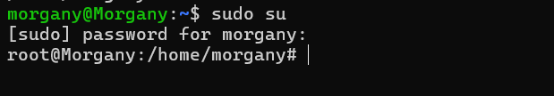

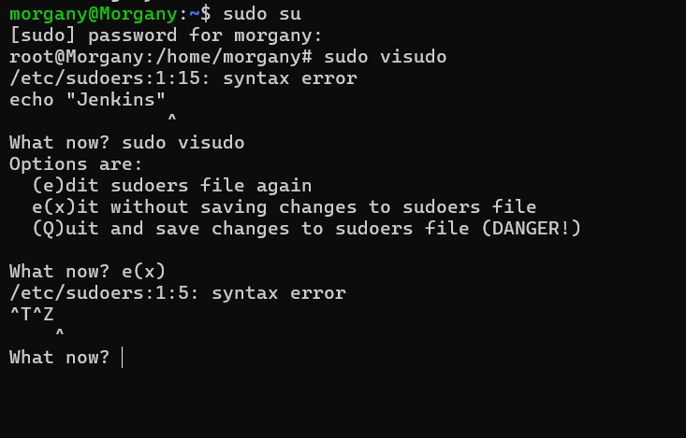

1. Updates the package list and installs the latest updates.
2. Installs Nginx if it’s not already installed.
3. Starts Nginx and enables it to run at system startup.
4. Restores the default Nginx web page.
5. Restarts Nginx to ensure changes take effect.

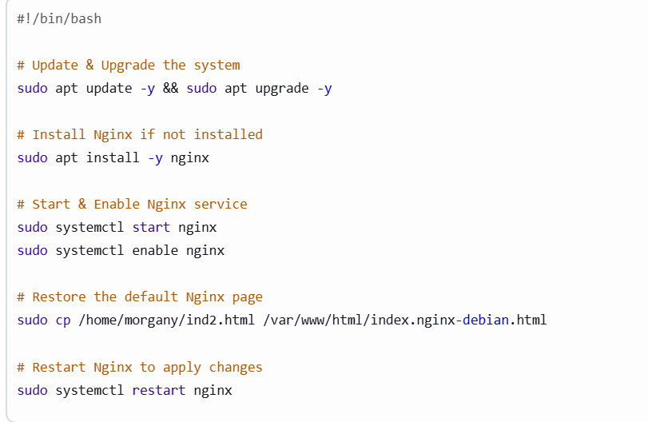

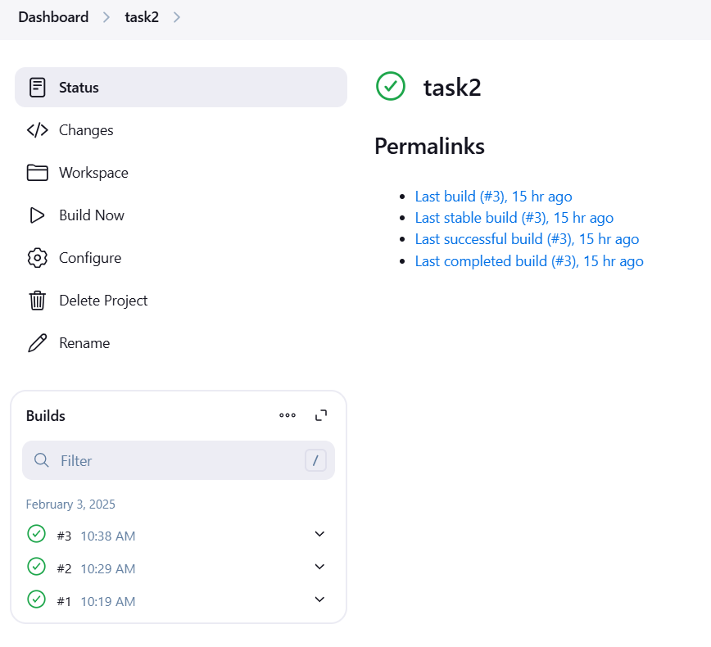

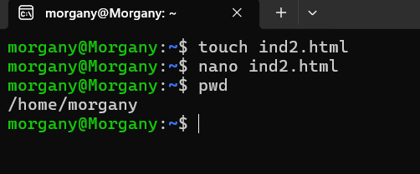

**OUTPUT:**

